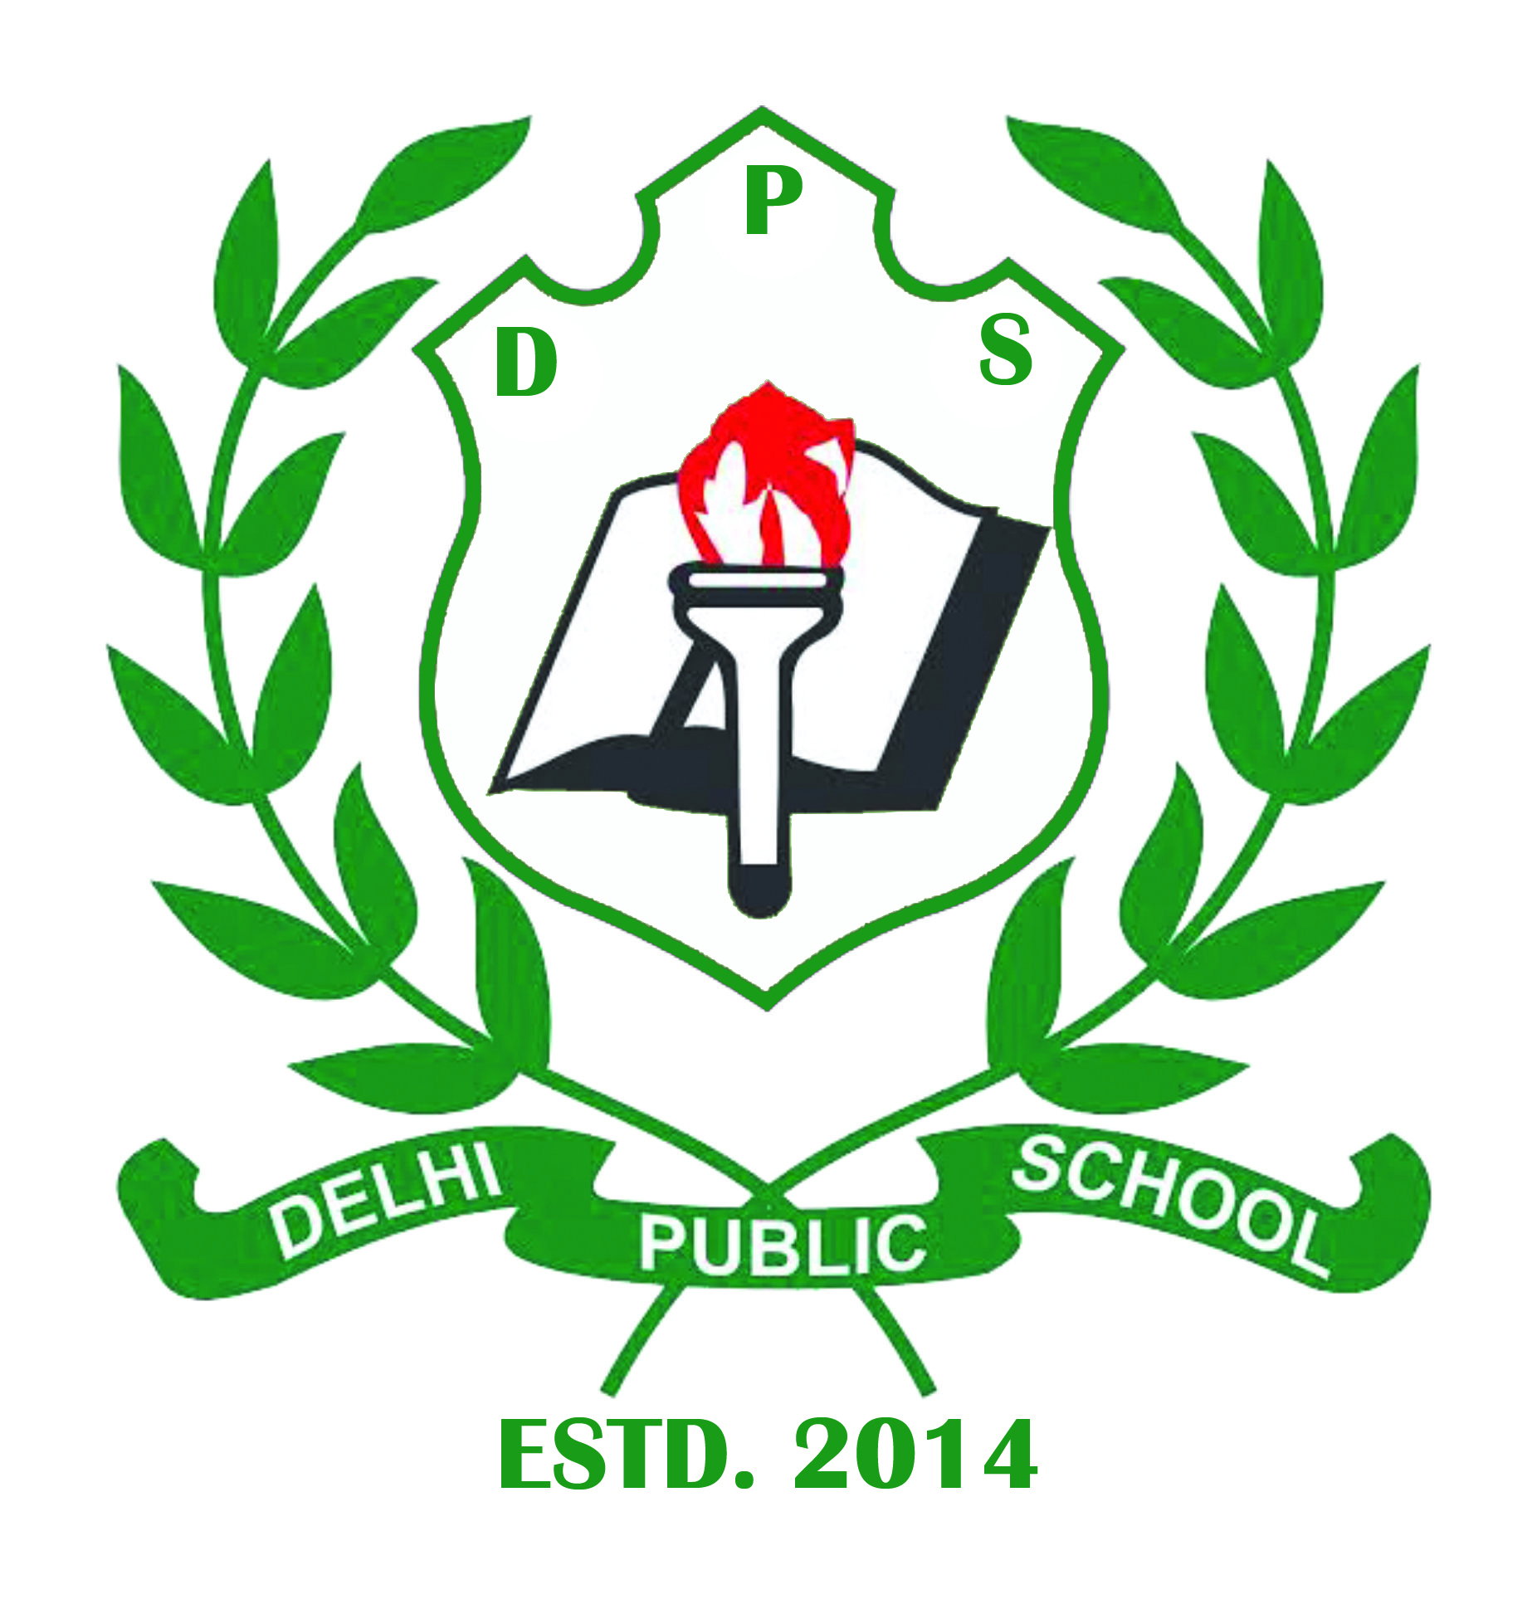

DELHI PUBLIC SCHOOL, PAKUR

Affiliated to C.B.S.E., New Delhi, Up to **10 +2 Level**

(Affiliation Number-3430354)

**Academic Session 2025 - 26**

Dear Students,

Vacations are the most attractive and desirable part of school life! It is time again for a fun filled and relaxing summer break. However, during the scorching summer month, when you are locked up inside your homes, time must be spent meaningfully and interestingly. Keeping this in view, we have assigned Holiday Homework for you so that you remain connected with your studies. Also have lots of fun by pursuing your hobbies and enjoying yourselves with the family.

Suggested Do’s in summer break:

Do’s:

• Have Fun with your family at home.

• Try to engage yourself with some indoor games.

• Try to develop a kitchen garden by your own with the help of your parents.

• Try to indulge in your hobby like music, dance, painting, collection of leaves, making kites, etc.

• Eat healthy and nutritious food and drink lots of water and hydrating liquids.

• Eat Vegetables and one Fruit minimum every day.

• Wash your hand, with soap, before and after taking food.

• Give some time to your grandparents. Find out about your family tree, roots and culture from them.

* Get up early and go for jogging everyday with your Papa and Mummy or Grand Parents
* Help your parents in doing their house hold work.
* Read Newspaper if possible in English every day.
* Learn how to make minimum. 5 dishes at your home from your mummy (Not for Nur. To II).
* Make a rough N.B. Learn and write 5 typical words of English their meaning and their usages.
* To improve your handwriting kindly writes one page of English and Hindi cursive Handwriting.
* Complete your holiday Home work in a very neat and clean Handwriting.
* Trim your Hair and Nails at regular Interval.

Don’ts:

• Consume oily and junk food.

• Spend too much time with computer and mobile games.

* Lend your note books/books to others.
* Waste your time roaming here and there in scorching heat.

Note:-

1. This Holiday Home Work will be taken in to consideration as a subjective enrichment activity. Hence, Mandatory to submit by everyone.
2. The summer vacations commence from 18TH May 2025 to 15th June 2025. The School will re-open on 16th June 2025 with summer timings i.e. 7:00 a.m. to 12:30pm till further notifications.

HAPPY HOLIDAYS

J.K.Sharma

Principal

Delhi Public School,

Pakur-816107

(Jharkhand)



DELHI PUBLIC SCHOOL, PAKUR

Affiliated to C.B.S.E., New Delhi, Up to **10 +2 Level**

(Affiliation Number-3430354)

CLASS -Nursery

|  |  |  |
| --- | --- | --- |
| Serial No. | Subject | Homework |

|  |  |  |
| --- | --- | --- |
| 1. | Maths | Oral- 1 to 50 forward counting  10 to 1 backward counting  Maths worksheet from activity book -pg no.-22,23,24,25,26  Counting stars numbers 1 to 50-pg no.11 to 31 |
| 2. | Hindi | बालगीत-मोटू राम ,बिल्ली,हाथी वर्णमाला मंजरी-pg no.10,14,18  वर्णमाला लेखन-pg no.11 से 20  Hindi worksheet from activity book-50 to 53 |
| 3. | English | Rhymes-Jingle bells, Rain Rain Go away, Early to Bed  Alphabet Giggle-pg no 3 to 10  Oral- vegetables name, fruits name, colours splash, Body Trip,My five senses  Mastering Capital Letters-pg no.5 to 15  English worksheet from activity book-pg no 4 to 16 |
| 4. | Evs | EVS -ch 3,8  EVS worksheet -pg no.-31 to 35 |